**CD LAB PROGRAMS**

1. **LEX Program to count the number of vowels and consonants in a given string.**

**Program:**

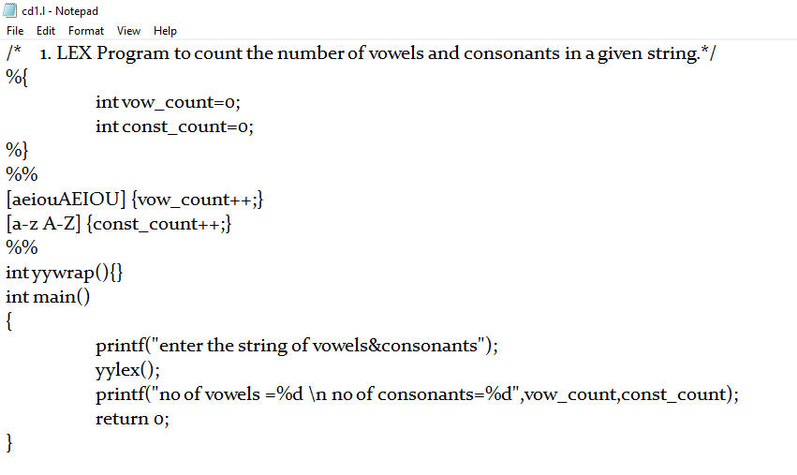

**Output:**

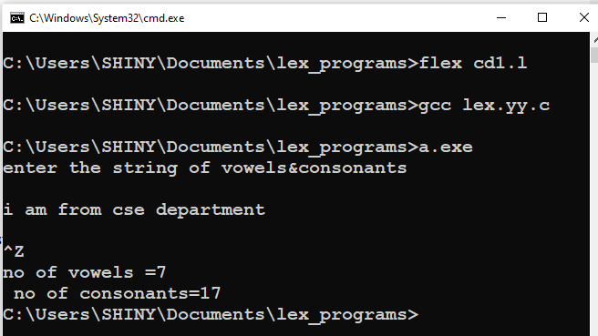

1. **LEX Program to count the number of lines, words, and characters in the input.**

**Program:**

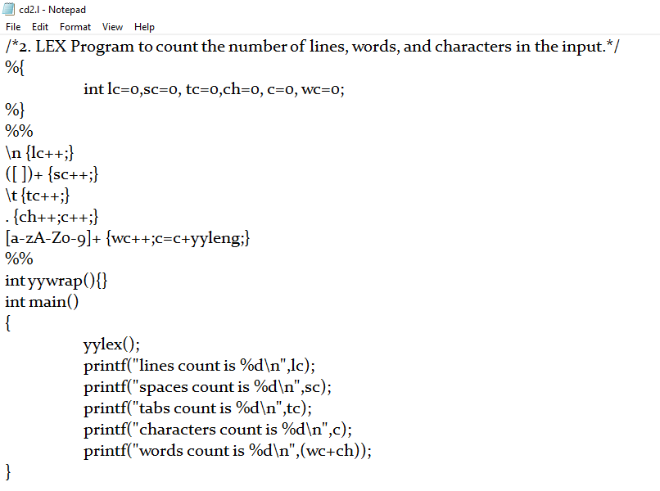

**Output:**

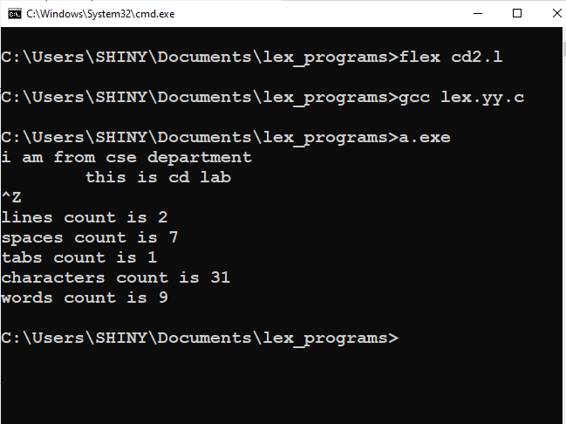

1. **LEX Program to count the number of integers and floating point numbers appearing in the input.**

**Program:**

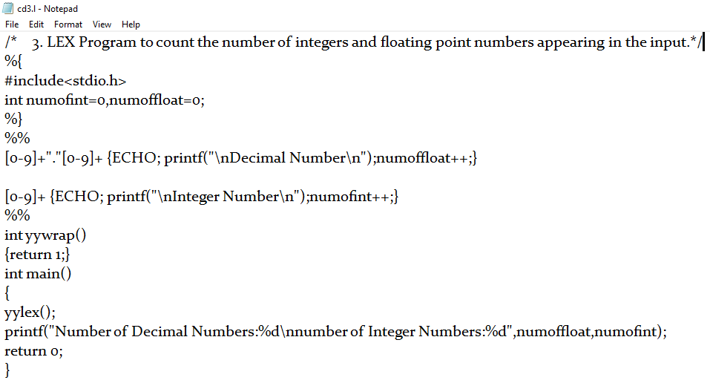

**Output:**

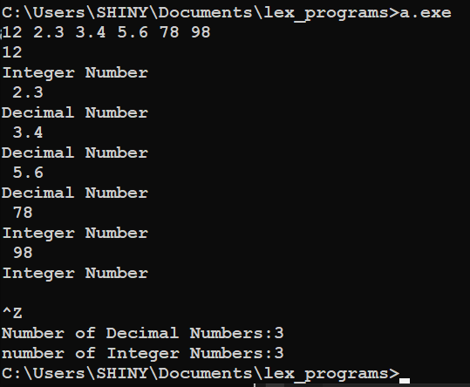

1. **LEX Program to list out all words of length three, starting with "A".**

**Program:**

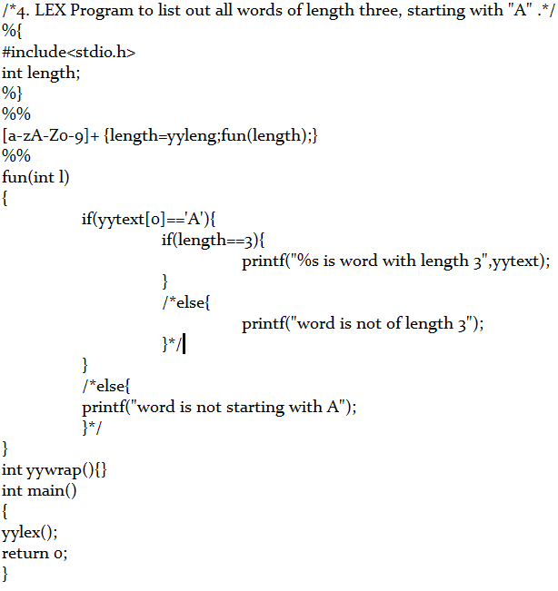

**Output:**

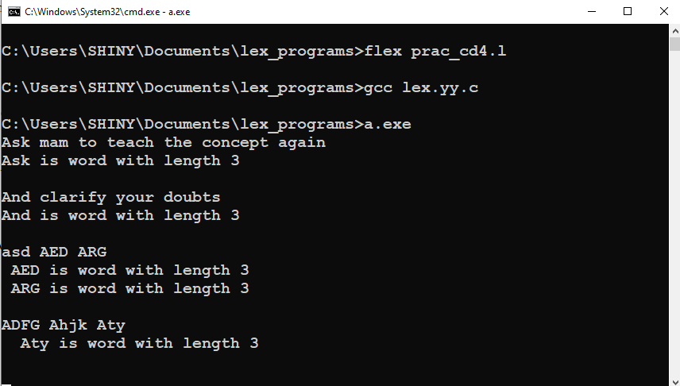

1. **LEX Program to list out all C-like comments (both single line and multi line comments) from a text file.**

**Program:**

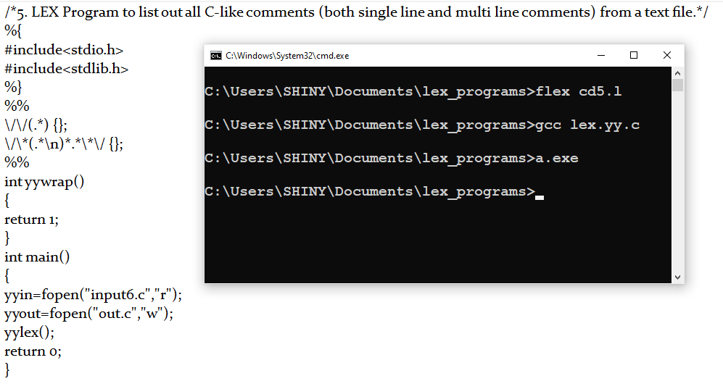

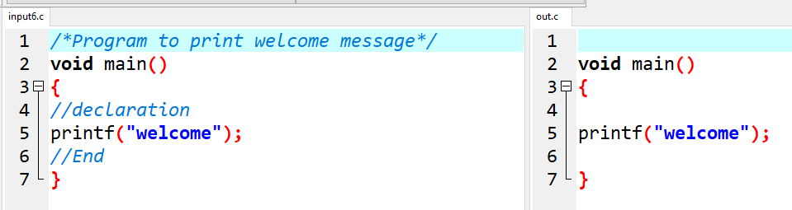

1. **Write a C program to find FIRST.**

**Program to find First:**

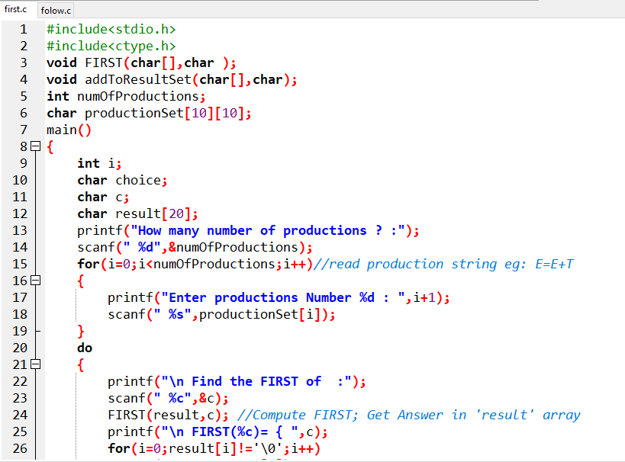

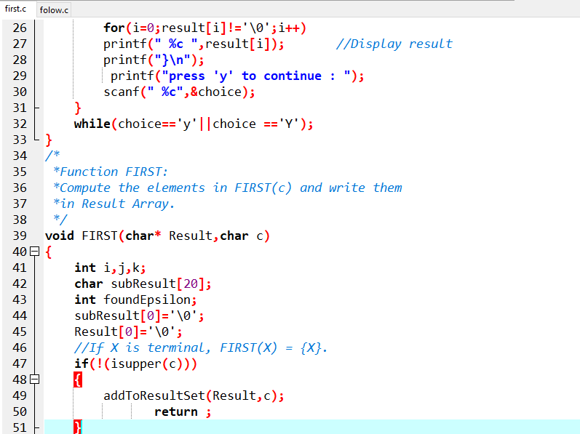

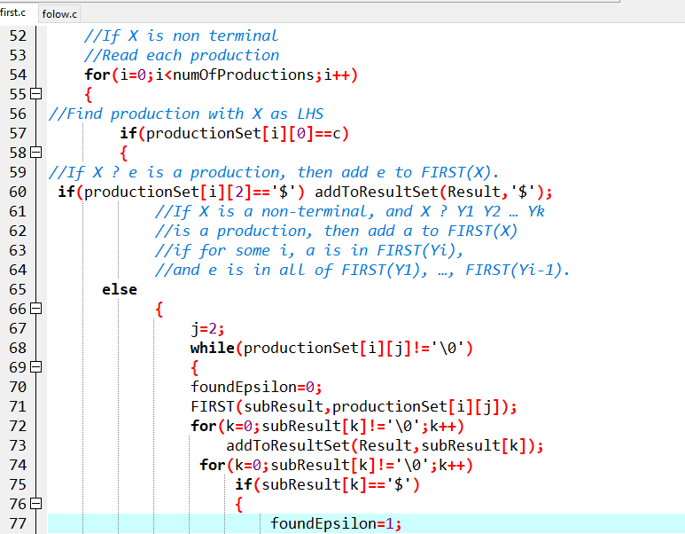

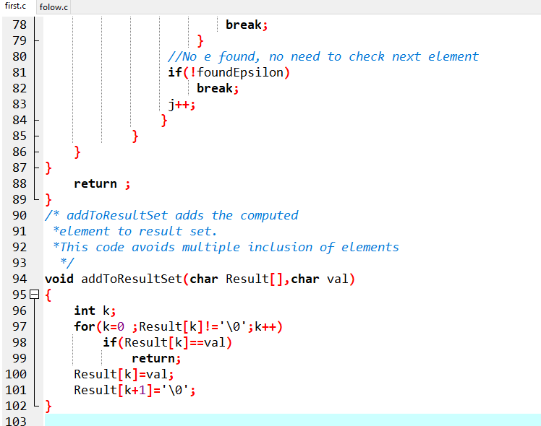

**Output:**

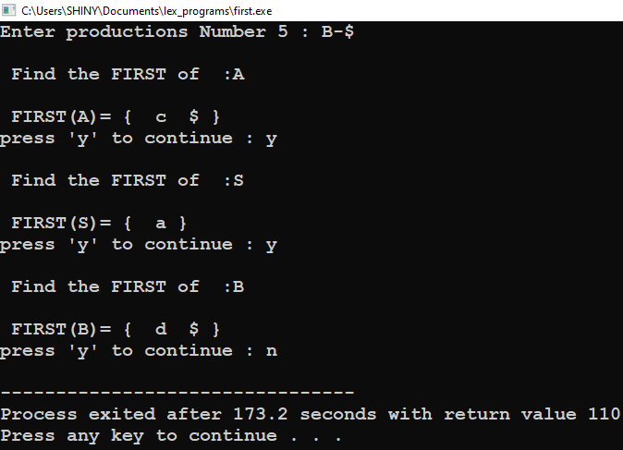

1. **Write a C program to find FOLLOW.**

**Program to find Follow:**

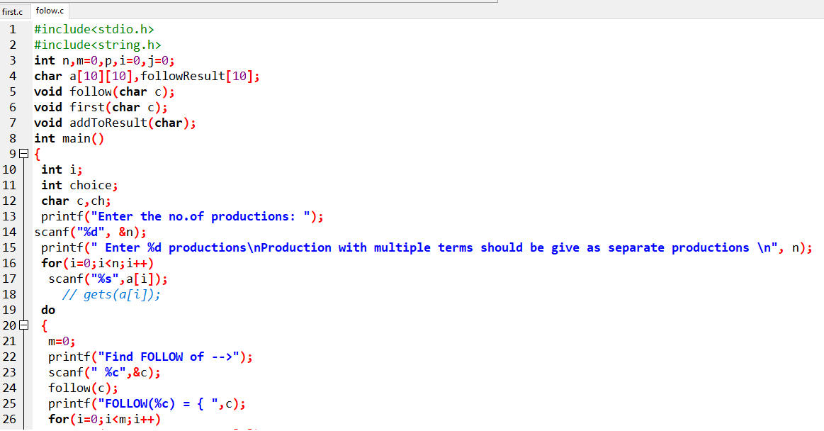

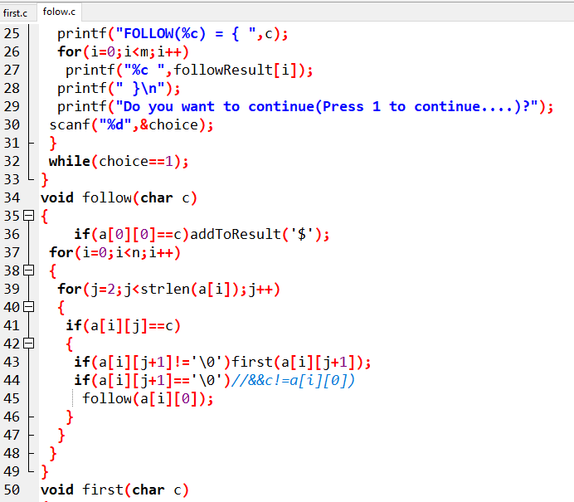

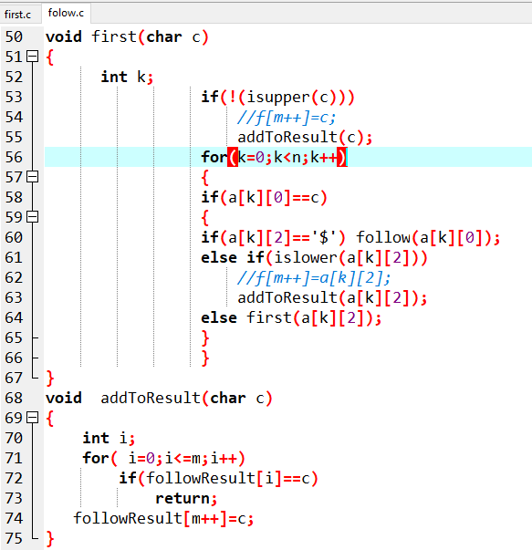

**Output:**

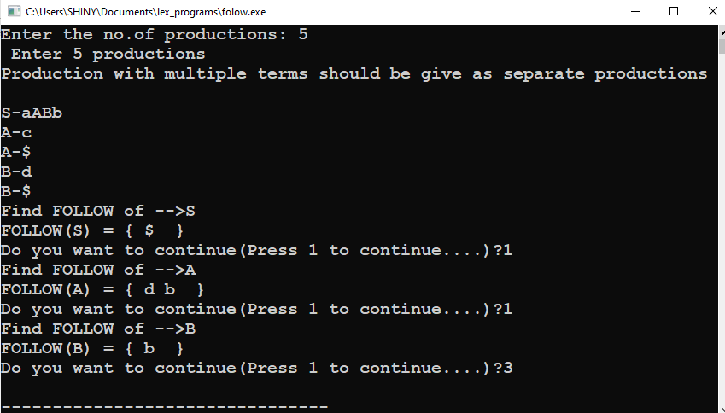

1. **Calculator program using yacc tool**

**Program:**

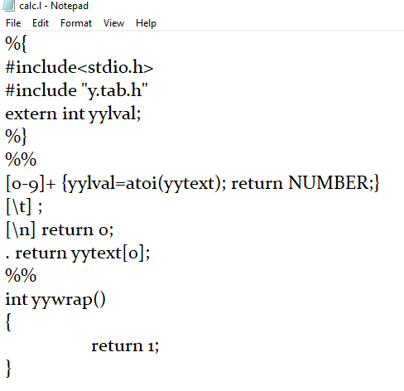

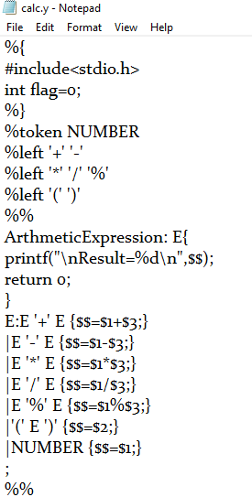

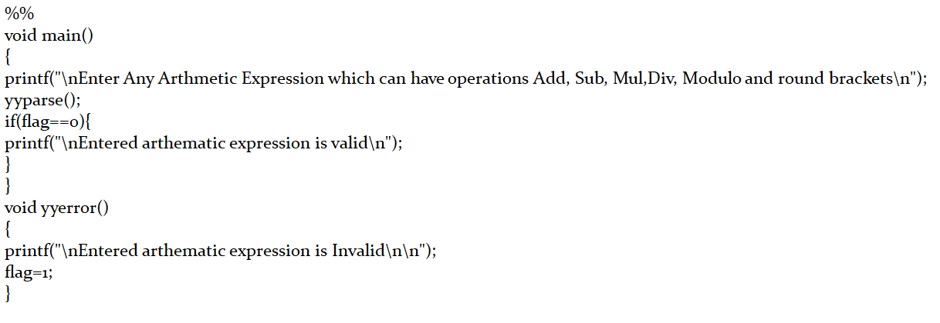

**Output:**

